18.44: a) 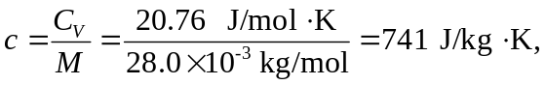

which is 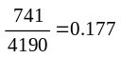 times the specific heat capacity of water.

b) 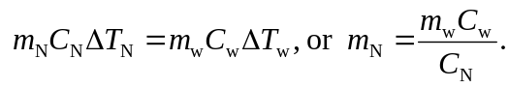 Inserting the given data and the result from part (a) gives 